**INTEGRATING PARSONS PUZZLE INTO MYUNI**

BUSINESS CASE AND DRAFT PLAN

**Prepared by:**

Jialun Han

Neha Wali

Peiting Sun

**Table of Contents**

**Executive Summary --------------------------------------------------------------------**

1. **Project Background and Description -----------------------------------------------**
2. **Project Goals -----------------------------------------------------------------------------**
3. **Extension of the Project ----------------------------------------------------------------**
4. **Implementation and Schedule Plan --------------------------------------------------**
5. **Roles and Responsibilities -------------------------------------------------------------**
6. **Communication Plan -------------------------------------------------------------------**
7. **References---------------------------------------------------------------------------------**

**EXECUTIVE SUMMARY**

The Project has been assigned to us by the course co-ordinator of Master of Computing and Innovation to provide a solution for integrating the Parson’s Puzzle into MyUni. Our project is to design and develop a universal design of parson’s puzzle and implementing the design into a customised H5P function which will be integrated with the canvas interface.

This document is therefore produced to provide the methodology and justification for undertaking the project based on the estimated time and effort for development and the anticipated project deliverables for iteration 1. It covers the business case and project plan.

To achieve the deliverable, we have divided the project into various phases as the project life cycle. This would help us achieve our goals on a scheduled date and would keep us on track. The project life cycle is divided into 5 phases, which includes project allocation, project initiation, project planning, project execution, and project closure. Project will be successfully completed after a period of 12 weeks.

1. **PROJECT BACKGROUND AND DESCRIPTION**
   1. **Project background**

Programming essentials: Concepts, Logic and Syntax.

**Universal Learning pattern of Beginners (Oyelere et. al, 2017):**

**Problems faced by Novice Programmers (Robins et al., 2003):**

These problems need to be addressed to make sure that the students are learning efficiently and can practise the theoretical concepts, to gain practical experience.

* 1. **Project Overview**

Currently, parsons’ puzzles are mainly used in programming. The project includes creating a universal design that can also be used in other subjects. For example, it can be used for Sequential chemical equations and mathematical proofs. To incorporate functional parsons puzzle into MyUni, there’s a need to develop a reusable interactive html5 content. There are some html5 contents like arithmetic quiz, drag the words, fill in the blank already in the library. But there is no existing content type for parson’s puzzle.

1. **PROJECT GOALS**

The objective of this project is to design and develop a universal design of parson’s puzzle and implement it into customised H5P, that will transform the process of learning for students. The project will include the following goals:

* Gather information, research and design a universal parsons puzzle which can be implemented for the subjects where algorithmic thinking is required.
* Development of environment settings.
* Implementation of parson’s puzzle H5P content.
* Integrating H5P with Drupal, further Canvas.

1. **EXTENSION OF THE PROJECT**

The following are associated benefits of Data Collection Analysis which can extend the project:

* Generating data about the topics which are hard to comprehend.
* Monitoring student progression.
* Analysing the learning pattern followed by each student.

1. **IMPLEMENTATION AND SCHEDULE PLAN**

Our project life cycle is divided into 5 phases, which includes project allocation, project initiation, project planning, project execution, and project closure. During the Period of our Project  there will be 1 significant milestone which includes a part of designing of the content and simple functionalities implementation of customised H5P and the final deliverable, which include complete designing the content and integrating H5P with Canvas, will be successfully completed after a period of 12 weeks.

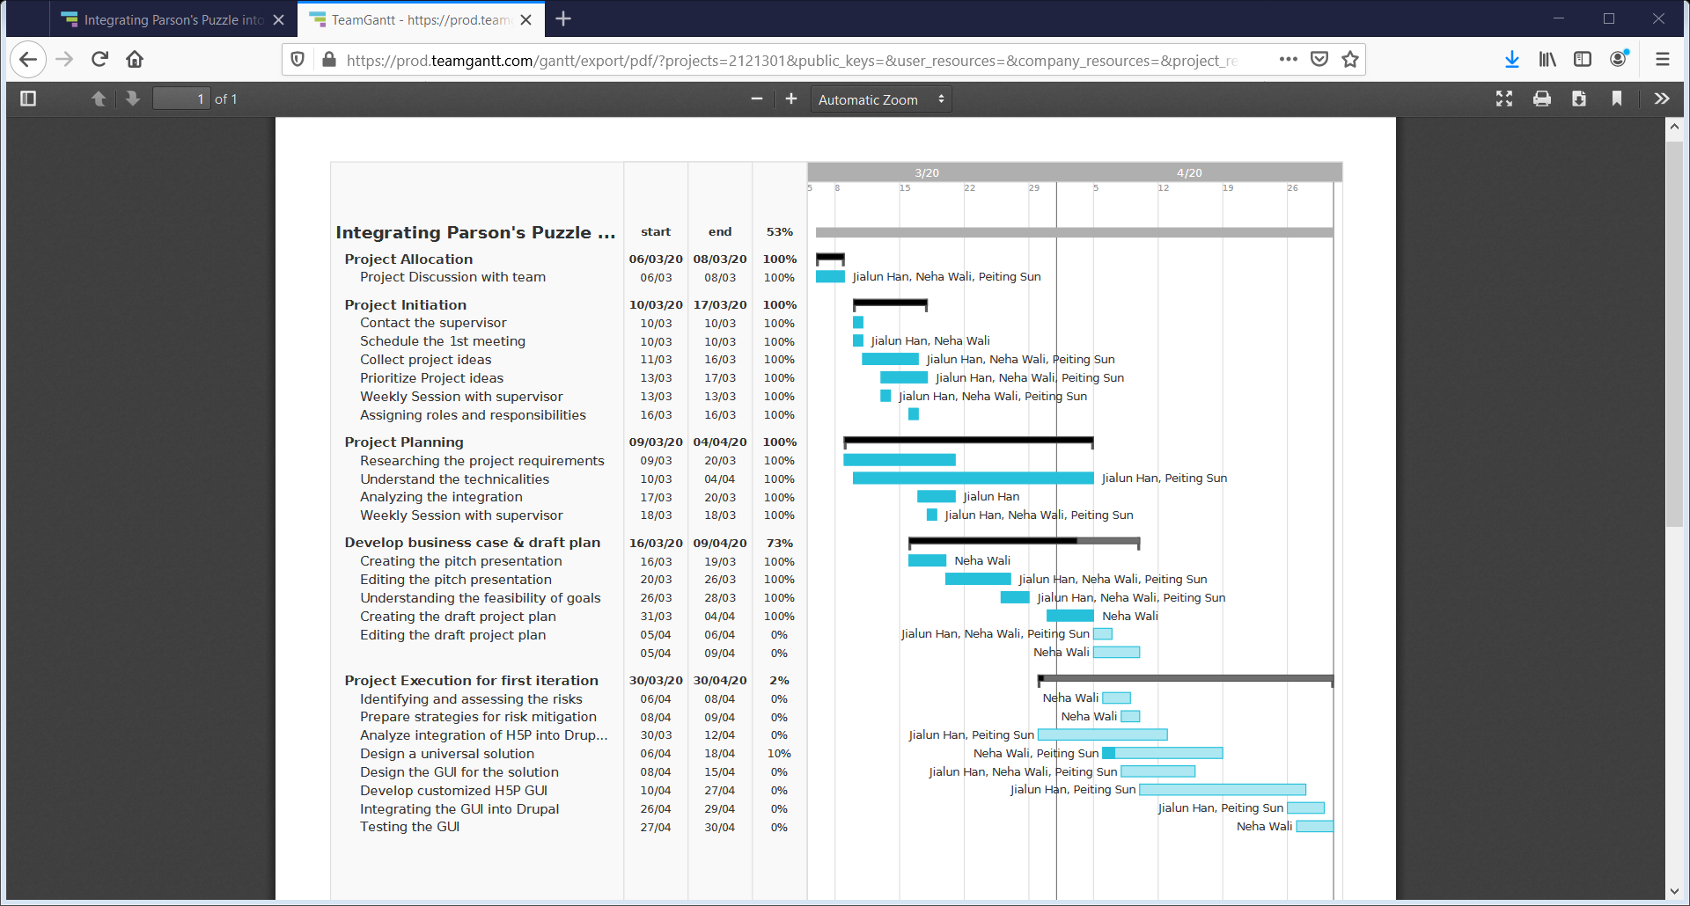

1. **ROLES AND RESPONSIBILITIES**

**Project Supervisor**

Name: Dr. Cheryl Pope

Role: Provides us guidance and hints to keep us moving forward. Helps by bringing clarity about project requirements, specification and the part of integrating the h5P into Canvas interface.

**Students**

The table below shows the team members roles and responsibilities:

|  |  |  |
| --- | --- | --- |
| ***Name*** | ***Roles*** | ***The rationale for Project role*** |
| Jialun Han | Developer | * Development environment settings. * Implementation of parson’s puzzle H5P content. * Integrating H5P with Drupal, further Canvas and MyUni. |
| Neha Wali | Project Manager | * Creation and development of documents. * Researching the designs and developing the universal design of the Parsons Puzzle. * Testing the functionalities implemented. * Managing the tasks and monitoring work status. |
| Peiting Sun | Quality and Design Analyst | * Development environment settings. * Integrating H5P with Drupal. * Setting up design tools. * Research on designing parson puzzle in coding side. |

1. **COMMUNICATIONS PLAN**

We have 1 meeting per week scheduled within our supervisor Dr. Cheryl Pope, whenever she is available within a week regarding the project updates. The meeting is held through zoom is intended to clarify the doubts, if we have and the way to approach the project so that it is as feasible as possible. We shall get ideas and suggestions regarding the steps to be taken to further our project. An additional meeting will be scheduled as required, which shall be determined by the group members and the supervisor.

All of us are working at our home. We are working on our project every week and schedule meetings twice a week, one in weekdays and one in weekend. We discuss the part that we have done and discuss our doubts and ask for clarifications from each, if needed. We brainstorm for any other solution that might be better. This has helped to identify the problem in our ideas and how would we be tackling those situations.

We also have created a group on Facebook and WeChat where we communicate and constantly keep on updating about our project. Also, we are using university email as well as GitHub where we are uploading all the works that we are doing so that all the members would be able to see and get updated about each member’s status.

**REFERENCES**

* Robins, J. Rountree and N. Rountree, "Learning and teaching programming: A review and discussion," Computer Science Education, vol. 13, pp. 137-172, 2003.
* S. S. Oyelere, J. Suhonen, T. H. Laine, “Integrating Parson’s Programming Puzzles into a game-based mobile learning application”, pp. 158-162, 2017.
* J. Ericson, “Evaluating the Efficiency and Effectiveness of Adaptive Parsons Problems”, 2018.
* Amruth N. Kumar, “Epplets: A Tool for Solving Parsons Puzzles”,pp. 527-532, 2018
* P. Denny, A. Luxton-Reilly and B. Simon, “Evaluating a new exam question: Parsons problems” pp113–124, 2008